## INFSCI 2710 Database Management, Fall 2018

### Homework 2: Relational Algebra, SQL

###### By JING PANG, JIP45

Q1[5pt] Count the number of instructors form Physics department.

Answer:

SELECT count(DISTINCT ID) FROM instructor WHERE dept_name = 'Physics'

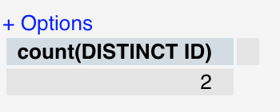

Q2[5pt]: Find the names of courses in Computer science department which have 3 credits.

Answer:

SELECT title FROM course WHERE dept_name = 'Comp. Sci.' AND credits = 3



Q3[5pt]: Find all the courses’s name taken by student 98988

Answer:

SELECT c.title   
FROM course c, takes t   
WHERE c.course_id = t.course_id AND t.ID = 98988

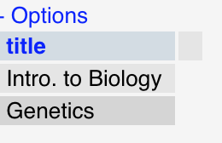

Q4[10pt]: As above but show the average salary of all the instructor of those courses taken by student 98988.

Answer:

SELECT AVG(salary)   
FROM takes ta, teaches te, instructor i  
WHERE te.course_id = ta.course_id AND te.sec_id = ta.sec_id   
 AND te.semester = ta.semester AND ta.ID = 98988 AND te.ID = i.ID

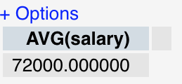

Q5[10pt]: Find the students’ name who take the course in the different department as the student.

Answer:

SELECT DISTINCT name   
FROM takes t, course c, student s  
WHERE t.course_id = c.course_id AND t.ID = s.ID AND c.dept_name <> s.dept_name

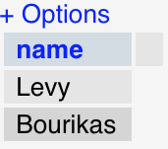

Q6[10pt]: Find the maximum and minimum enrollment across all sections, considering only sections that had some enrollment, don't worry about those that had no students taking that section.

Answer:

SELECT  
 MAX(t.enrolls) AS max_enrolls, MIN(t.enrolls) AS min_enrolls  
FROM  
(  
 SELECT course_id,sec_id,semester,year,COUNT(DISTINCT ID) AS enrolls  
 FROM takes  
 GROUP BY course_id,sec_id,semester,year  
) t

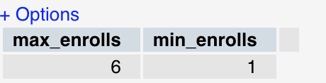

Q7[5pt]: Find each student ID and the count of courses he/she takes. Display the student ID and course count.

Answer:

SELECT   
ID,count(DISTINCT course_id) AS NumberOfCourseTaken   
FROM takes   
GROUP BY ID

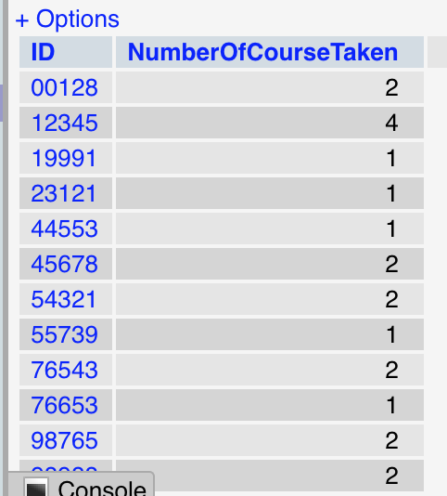

Q8[10pt]: Find the student who take more courses than the other students. Display the student ID and course count.

Answer:

SELECT  
 temp.ID  
FROM  
(  
 SELECT  
 ID,COUNT(DISTINCT course_id) AS NumberOfCourseTaken  
 FROM takes  
 GROUP BY ID  
) AS temp  
WHERE temp.NumberOfCourseTaken IN (  
 SELECT MAX(NumberOfCourseTaken)  
 FROM  
 (  
 SELECT ID,COUNT(DISTINCT course_id) AS NumberOfCourseTaken  
 FROM takes  
 GROUP BY ID  
 ) AS temp  
)

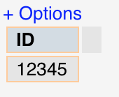

Q9[10pt]: Find the student and the largest classroom (biggest room capacity) among all the class he/she has taken. Display the student ID and the room capacity.

Answer:

SELECT  
 t.ID, MAX(c.capacity) AS max_capacity  
FROM takes t, section s, classroom c  
WHERE t.course_id = s.course_id   
 AND t.sec_id = s.sec_id   
 AND t.semester = s.semester   
 AND s.room_number = c.room_number  
GROUP BY t.ID

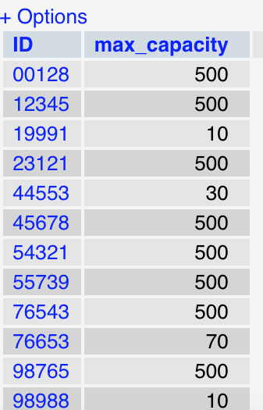

Q10[15pt]: Find the student (ID) from history department who has taken classes in the largest classroom (biggest the room capacity) compare with other students in history department. Display the student ID and the corresponding room capacity.

Answer:

SELECT  
 temp.ID, temp.max_capacity  
FROM  
 (  
 SELECT st.ID, MAX(c.capacity) max_capacity  
 FROM student st, takes t, section se, classroom c  
 WHERE st.dept_name = 'History'   
 AND st.ID = t.ID   
 AND t.course_id = se.course_id   
 AND t.sec_id = se.sec_id   
 AND t.semester = se.semester   
 AND se.room_number = c.room_number  
 GROUP BY st.ID  
) temp  
WHERE max_capacity IN(  
 SELECT  
 MAX(temp.max_capacity)  
 FROM  
 (  
 SELECT st.ID, MAX(c.capacity) max_capacity  
 FROM student st, takes t, section se, classroom c  
 WHERE st.dept_name = 'History'   
 AND st.ID = t.ID   
 AND t.course_id = se.course_id   
 AND t.sec_id = se.sec_id   
 AND t.semester = se.semester   
 AND se.room_number = c.room_number  
 GROUP BY st.ID  
 ) temp  
)

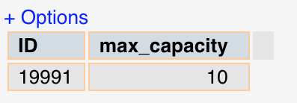

Q11[15pt]: Find the department that its students take more courses on average than other departments. Display the department, and average count of courses that its student take.

Answer:

SELECT  
 temp.dept_name, AVG(temp.NumberOfCourses) avgcourses  
FROM  
(  
 SELECT s.dept_name,s.ID,COUNT(DISTINCT course_id) NumberOfCourses  
 FROM student s, takes t  
 WHERE s.ID = t.ID  
 GROUP BY s.dept_name, s.ID  
) temp  
GROUP BY temp.dept_name  
HAVING AVG(temp.NumberOfCourses) >= ALL(  
 SELECT AVG(temp.NumberOfCourses) avgcourses  
 FROM  
 (  
 SELECT s.dept_name, s.ID,   
 COUNT(DISTINCT course_id) NumberOfCourses  
 FROM student s, takes t  
 WHERE s.ID = t.ID  
 GROUP BY s.dept_name, s.ID  
 ) temp  
GROUP BY  
 temp.dept_name  
)

